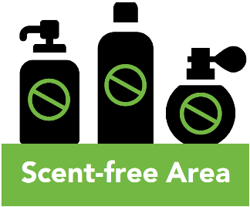
Memorandum
To: | [Insert addressee]
From: | [Insert sender]
Date: | [Click to select date]
Re: | Fragrance/scent-free workplace environment
Exposure to perfumes and other scented products can trigger very serious health reactions in individuals with asthma, allergies, migraines or multiple chemical sensitivities.
The health effects of fragrances – ranging in severity from mild to debilitating – can include: headaches, migraines, dizziness, nausea, fatigue, shortness of breath and wheezing. For some people, especially those with asthma and other respiratory disorders, exposure to fragrances can trigger the need for emergency medical treatment.

Perfumes and colognes are considered the most concentrated form of fragrance, however fragrances can be found in a wide range of products including soaps, shampoos, deodorants, hairsprays and cosmetics.
To protect our colleagues with chemical sensitivities, I am asking for your cooperation in helping to create a ‘scent-free’ environment:
- Avoid wearing scented personal care products such as perfume, cologne, aftershave, scented lotions or creams for the body, face or hands. Most brands have fragrance-free products available.
- Post a scent-free area poster in your workspace:
- [Insert other measures as appropriate]

Thank you for helping to create a safe and healthy environment for everyone. If you have any questions, please contact [department point person’s name and contact info.].

