Dear Joint Health and Safety Committee (JHSC) Participants,
The Ministry of Labour (MOL) developed a learner portals for the Certification Management System (CMS) accessible by SkillsPass™ where you can quickly and easily access, view, print and share your Chief Prevention Officer (CPO) training records online and on your smartphones 24/7.
If you’ve taken JHSC training prior to March 2019, then you are required to link your MOL Learner ID to a new or existing SkillsPass™ account for online credential tracking. Please follow the instructions below.
- Complete and submit the Link Account Form. You will need your: First & Last Name, MOL Learner ID*, Email Address, Postal Code and Year of Birth.

*If you do not know your Learner ID, please contact Irene Tang (irn.tang@utoronto.ca).
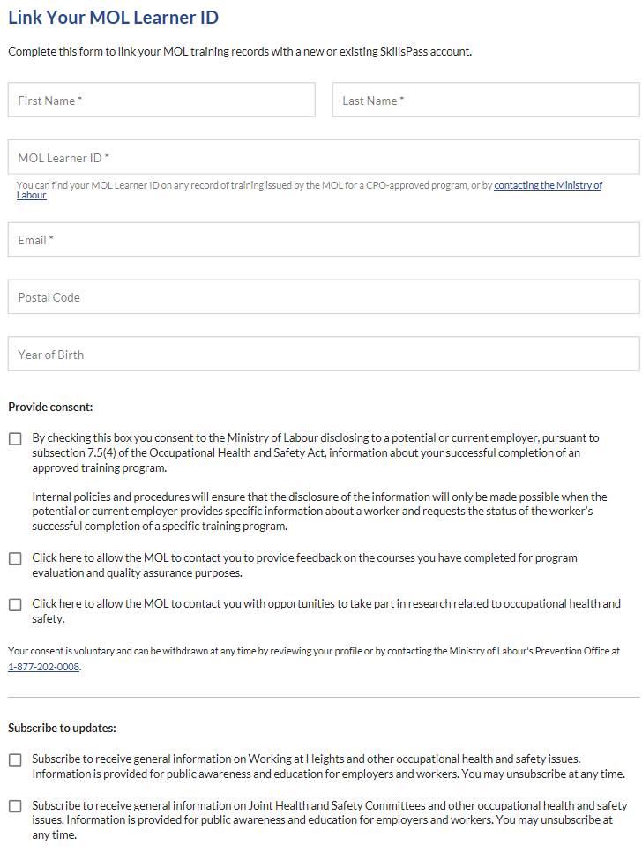

- Please select this box if you provide consent to the MOL to disclose to your employer your training record.
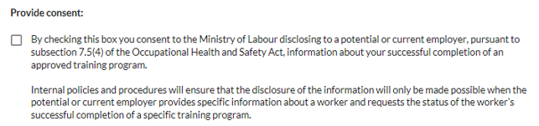
- After the request has been sent, you will see:
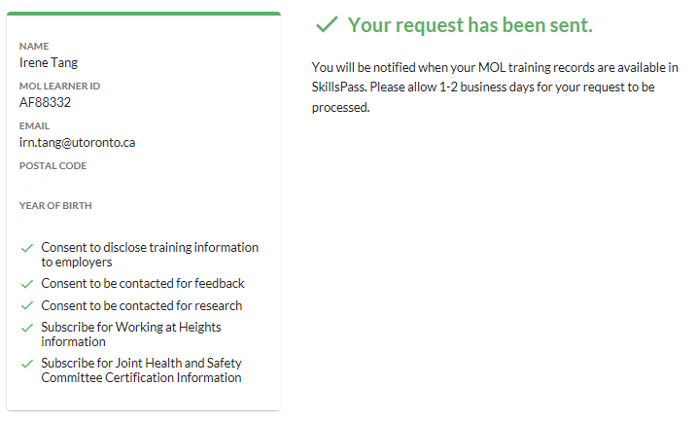
- An email will be sent to you confirming the linkage of your account and an account can be created.
