PM
Personal Mobility Devices (PMDs)
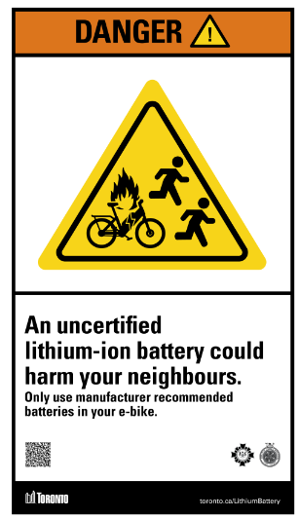
PMDs include bicycles, kick-scooters, rollerblades/ roller-skates, skateboards and electric-powered devices (e.g. e-bikes, hoverboards, self-balancing devices, etc.).


- Charge before coming to the University
Source: City of Toronto
- Batteries / charger – recognized certification markings such as CSA, CUL, cETL.
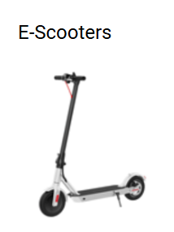

- E-scooters – Store off-campus. They are illegal to ride in Toronto. Do NOT use on Campus or City sidewalks/pedestrians.
Source: City of Toronto
- Do not use or ride PMDs within the University buildings.
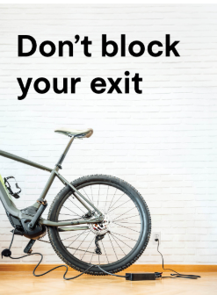
- Do not store it in walkways, corridors, near entrances / exits or other areas where they become a trip hazard.
Source: UL Standards & Engagement
If you have any questions/concerns, contact [divisional contact information].
Template date: April 3, 2025

