Instructions - Asbestos Data website
- Open internet browser
- Type in https://asbestos.fs.utoronto.ca
- Select either “Public” or “Internal” access
There are two versions of the website: a Public version and an Internal version.

Public access:
- No login is required.
- Access to Asbestos Survey Reports only. Survey Reports are updated annually as required by regulation.
- Search for Asbestos Survey Reports by selecting, “Campus” and then “Building.” Click on “View Report.”

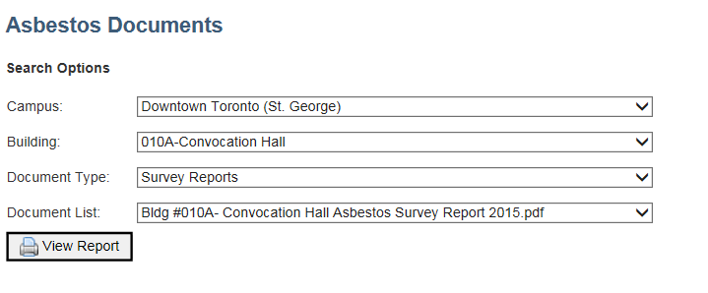
Internal access:
- Requires UTORid and password. If you have forgotten your UTORid or password, go to the UTORid Account Management website: https://www.utorid.utoronto.ca/
- This part of the website contains other documents on asbestos and designated substances for the St. George Campus, such as fireproofing floor plans, consultant survey reports, designated substance report summaries, asbestos building summaries and a campus-wide master summary of asbestos materials. These additional documents are used by members of the St. George Campus to identify the location of asbestos and other designated substances prior to renovation, construction and repair work.
- Ability to search for asbestos information by room and building. Information in the Home page, (4a, below) is updated throughout the year.

- Internal Access – Instructions:

4a) This is the Home page – Asbestos Information Search
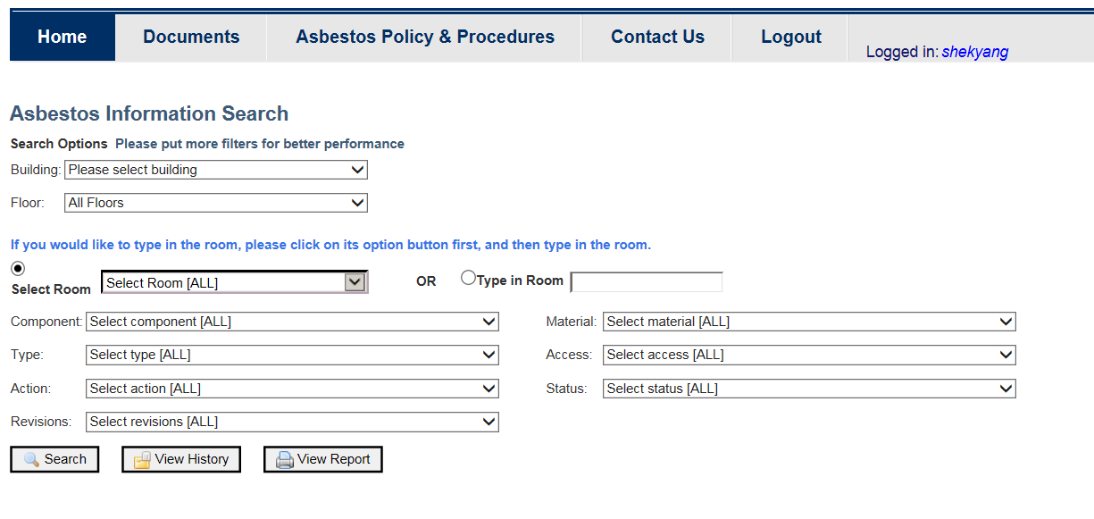

4b) Example of search results for a specific building:
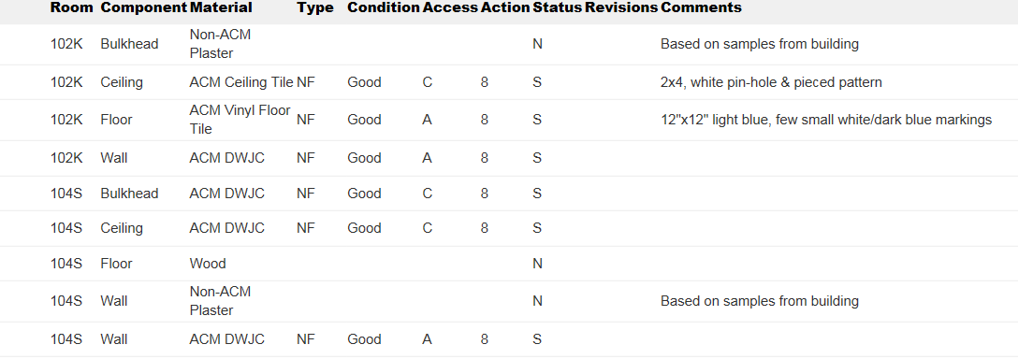

4c) If you do not know some of the codes in the search results, the definition of the codes are in the dropdown menus.
