EHS002 Basic Health and Safety Awareness Training – How to find training records in the Manager Self-Serve (MSS) - August 2018
- Log into the Employee Self-Service: http://aws.utoronto.ca/services/employee-self-service-ess/ OR the Manager Self-Service” http://aws.utoronto.ca/services/manager-self-service-mss/
- Click the “Manager Self-Service” on the right hand side and then click “Reports”
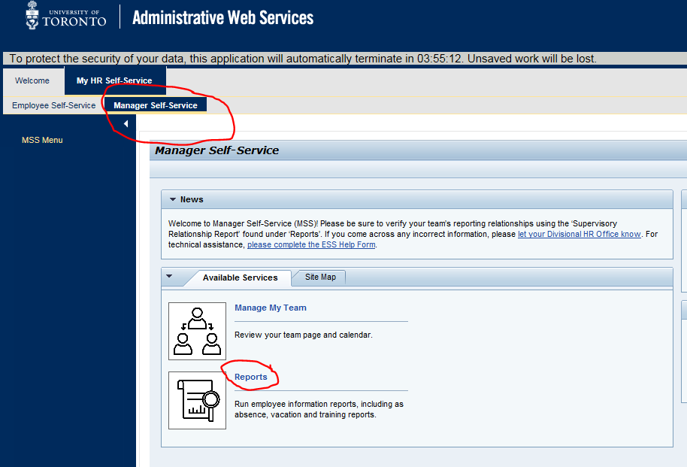
- Under “My Reports,” click “University Training Report.”
- Entering the appropriate Reporting Period and then click “Run Report.”
- The training is called “Basic H&S Awareness”
