ACademic Study space
Non-public use
Template date Nov, 26, 2021

insert qr code

(if applicable)

IMPORTANT INFORMATION FOR USERS

BEFORE entry, individuals must ensure the following:
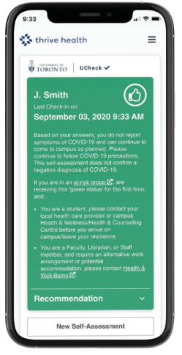
- COMPLETE UCheck (https://ucheck.utoronto.ca/) and receive a GREEN status
- [INSERT IF APPLICABLE] SCAN the above QR code and complete contact tracing information
- [INSERT IF APPLICABLE] SIGN in using the [log-book, online booking system or other method] to complete contact tracing information.
- WEAR a mask at all times
- DISINFECT surfaces after use with available wipes. Limit the number of items you touch.
- DO NOT eat or drink (use alternate/designated space with physical distancing to eat)
- WASH your hands often with soap and water or use alcohol-based hand sanitizer.
THIS SPACE IS MONITORED FOR COMPLIANCE
All personal information collected is protected in accordance with privacy requirements, including the Freedom of Information and Privacy Act. Records containing personal information collected at this academic study space for contact tracing purposes, such as building QR codes, will be destroyed after 30 days from the date of collection.

