
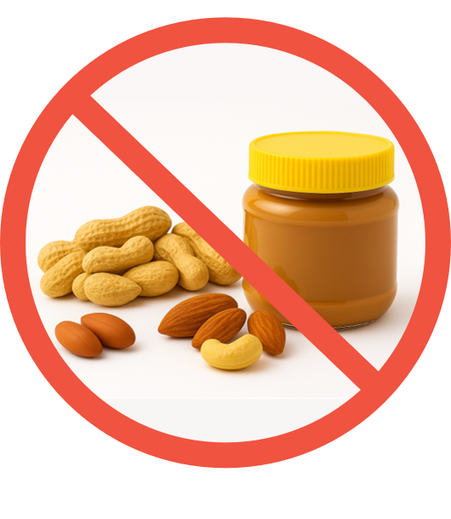
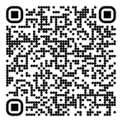
For more information on food allergies in the workplace, visit: http://uoft.me/FoodAllergy
No Nuts or Peanut
Products Allowed
Nut-containing foods include:
- Mixed nuts
- Nut-based butters and spreads
- Nut-based oils, sauces, and dressings
- Baked goods containing nuts
- Granola and energy bars
- Chocolate and candy containing nuts
Image generated with Microsoft 365 Copilot
Thank you for helping protect individuals with
severe, life-threatening nut allergies.
Revised Dec 2025
NUT-FREE ZONE

